Exercise 1 – Identify Potential Government Funding Sources

This learning activity is designed to familiarize you with public funding streams.

Instructions: Using the internet, your local phone directory or other resource, complete the following chart with the name, mailing address and web address of at least one government department/division located in San Diego County that is esponsible for overseeing or operating programs in at least three program areas of interest to you. A sampling of programs is provided below for reference, but you may include any program area of interest to you:

Aging Housing Economic Development
Arts Forestry Social Services
Education Fire & Safety Transportation
Health Seniors Environment

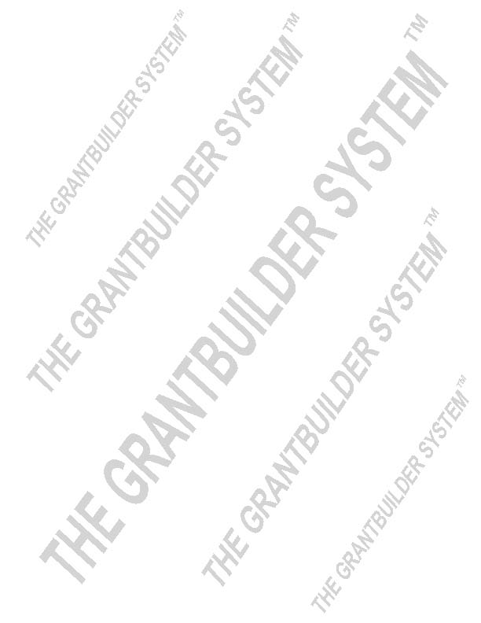  List name of the government dept. or division below: | Program 1: | Program 2: | Program 3:
Local/City

County

State

Federal

Locating Corporate Grants

Some corporations have separate foundations that handle all of their charitable grantmaking activities. (i.e. Avon Foundation, Ben & Jerry’s Foundation).

Some corporations process all of their charitable donations through specific departments or offices. The names of these departments will vary from company to company. To locate information on corporate grants, take the following steps:

Step 1: Type name of the corporation (Example: “Toyota”)

Step 2: If the existence of a corporate foundation isn’t readily apparent, look for department names similar to the ones in the list below:

charitable giving community involvement public support
charitable grants community relations foundations
community support community contributions philanthropy

Step 3: If you can’t find anything on the site related to grants, contact their corporate office via e-mail or phone by clicking on the “CONTACT US” tab. The information is sometimes located under the “ABOUT US” tab.

Make contact and ask for the contact person or division in charge of providing “support” for community programs. This individual will be able to let you know if the company offers grants. Some companies don’t give grants, but they may donate products or services. Be sure that your inquiry is a request regarding “support for community programs” so that you will have the opportunity to learn of “non cash” donations that might benefit your program.

Exercise 3 – Locating Grants on the Internet: Corporate Giving

Instructions: Find and review grant applications and information from at least three corporate or foundation funders. Indicate at least one program category for which the funder provides grants. Choose a corporation from the list below or select your own.

- Ford Motor Corporation - Nissan Foundation - Hewlett-Packard Foundation
- Ben & Jerry’s Ice Cream - Northrop Foundation - The Grammy Foundation
- Wells Fargo Foundation - Toyota Foundation - Nike Foundation

Corporate Funder | Program Category | Website

Grant Application Review Worksheet

Funder:
Website: | Primary Contact  Name:  Title:
Facebook:
Mailing Address:
 | E-Mail:
 | Phone:

Description of  application item | Notes
Application deadline(s)?
(Postmark date or delivery date? Indicate time zone for online submissions
Initial LOI? or Full Proposal?
Online, e-app or hard copy?
Funders’ mission/objectives?
Funding levels related to the age and size of your agency? (Minimum? Maximum? Average?)
Funding categories/ initiatives?
(Ongoing? Special focus?)
Funding restrictions?
(Geographic, activities, one-year)
Proposal review schedule?
(Committee, board, etc.)
Funding cycle?
(Schedule for announcement of awards? payments?)

Collaboration preferred or required?
Letter of Intent/Application?
(indicate major points and key details required)
- Maximum pages?
- Required information?
- Required attachments?

Description of  application items | Notes
Information required on staff positions that will play a key role? (resumes and/or job descriptions)
Funding history? Previous grantees? Amounts awarded?
Information on the scoring of application questions or sections?
Formatting and mailing/submission instructions

Attachments Required:
- Board information
(resumes, summary bios?)
- Proof of 501(c)(3)
- 509(a) status
- Proof of state’s nonprofit status
- Letters of support
Other:

Other:

Other:

Additional Notes:

