Grant Application Review Worksheet

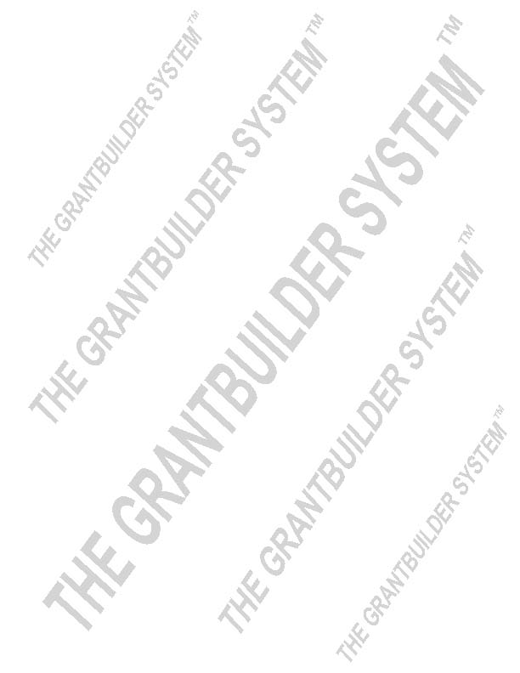
Funder:

Website: |  | Primary Contact  Name:  Title:
Mailing Address:
 |  | E-Mail:
 |  | Phone:
Application
Login Info:
Description of  application item | Notes
1. Application deadline(s)?
Postmark date or delivery date? Indicate time zone for online submissions
2. Board resolution required?
If yes, it will be necessary to get approval, with signature of Board President/Officer
3. Initial LOI? or Full Proposal?
4. Online or hard copy?
5. Funders’ mission/objectives?
6. Range/Amount of grant awards? (i.e. minimum, average, maximum; also indicate if funding amounts are related to the size and age of an agency)
7. Funding categories/ initiatives?
(Ongoing? Special focus?)
8. Funding restrictions?
(Geographic, activities, one-year)
9. Funding cycle?
(Schedule for announcement of awards? payments?)

10. Collaboration preferred or required?
11. Letter of Intent?
(indicate major points and key details required)
- Maximum pages?*
- Required information?
- Required attachments?

*Pertinent to hard copy applications

Description of  application items | Notes
12. Proposal Review Schedule?
Any indication of when a board, committee or other party reviews applications?

13. Information on how the application questions or sections will be scored?

14. Funding history? Previous grantees? Range of amounts awarded? Refer to funder’s 990 for details if needed

15. Formatting and mailing/submission instructions Special instructions regarding font size, margins (hard copies) or file formats for attachments (i.e. .pdf or .docx)

16. Attachments Required:
- - Board information? (resumes,
- summary bios or curriculum vitae?)
- - Proof of 501(c)(3)?
- - 509(a) status?
- - Proof of state’s nonprofit status?
- - Letters of support/MOU’s?
17. Information required on staff positions that will play a key role? (resumes and/or job descriptions)

18. Other:

19. Other:

20. Other:

Additional Notes:

